Brisbane VHF Group
From the President’s keyboard………….

The next meeting of BVHFG will be on Wednesday 27th October
Chermside Library from 18:30
Call 0407 799664 for entry as front door is locked after hours

The meeting will be ZOOM’d for those unable to attend in person
https://us06web.zoom.us/j/87062016984
This link has been e-mailed to you by Jason (Sec) in a separate message for easy access.

Good morning, everyone
Well, it looks as if Covid restrictions and lockdowns are going to be eased in time for Christmas. This is clearly very welcome news for all those who have been able to vaccinate. I won’t say any more on this subject but, with my medical hat on, still urge everyone to stay safe. Under the council rules the “normal” check in and social distancing requirements at the library will remain until we hear otherwise.

As we are often reminded, we are a VHF group, not just a microwave group. This week’s meeting will include a short video presentation on Sporadic E propagation, this being the major mode of DX propagation on the 6m band. This will be on the big screen at the meeting and on Zoom of course.

Last weekend the 122GHz Test and Tune-up Day was hosted by the Redcliffe and Districts Radio Club at their clubrooms. The meeting was well attended by members of both groups. Five VK3CV transceiver/transverter systems, in various stages of completion were tested, several for the first time and with varying levels of success. There is always room for development and improvement.
RDRC hosted a breakfast and lunchtime BBQ for those attending and the meeting was also supported by QSL-Comms a local supplier of most types of RF connectors and inter-series adaptors etc. I would like to thank the Redcliffe club, on everyone’s behalf, for the support and use of their facilities.

BVHFG Beacons
There has been progress with at least one the clubs beacon systems. Both are currently off-air however, after extensive repairs and upgrades by both Doug VK4OE and Stefan VK4CSD, the VK4RBB beacon system (432MHz through 24GHz) system is ready for reinstallation at the Eden’s Landing site.
With luck this should be reinstalled later this week and back on air before the weekend. All the
beacon outputs should be back up to previous levels. Thanks again to everyone who has been involved with the upgrades, repairs and installation on ‘4RBB
Minimal progress with reactivation of VK4RTT (2m-6m) beacon at this time – but we are still trying to get the machine back on air (from somewhere) ASAP and in time for the Spring-Summer VHF season which is almost upon us.

BVHFG Logo
Here are some more options that have been put forwards for a new club logo, intended for hats and shirts etc for members. These two “candidates” were provided by Scott VK4CZ. Representing both a microwave dish and a VHF Yagi, covering all the clubs’ activities, I personally like the second logo. Please feedback your preference or any alternative designs before we make a decision on a final design.

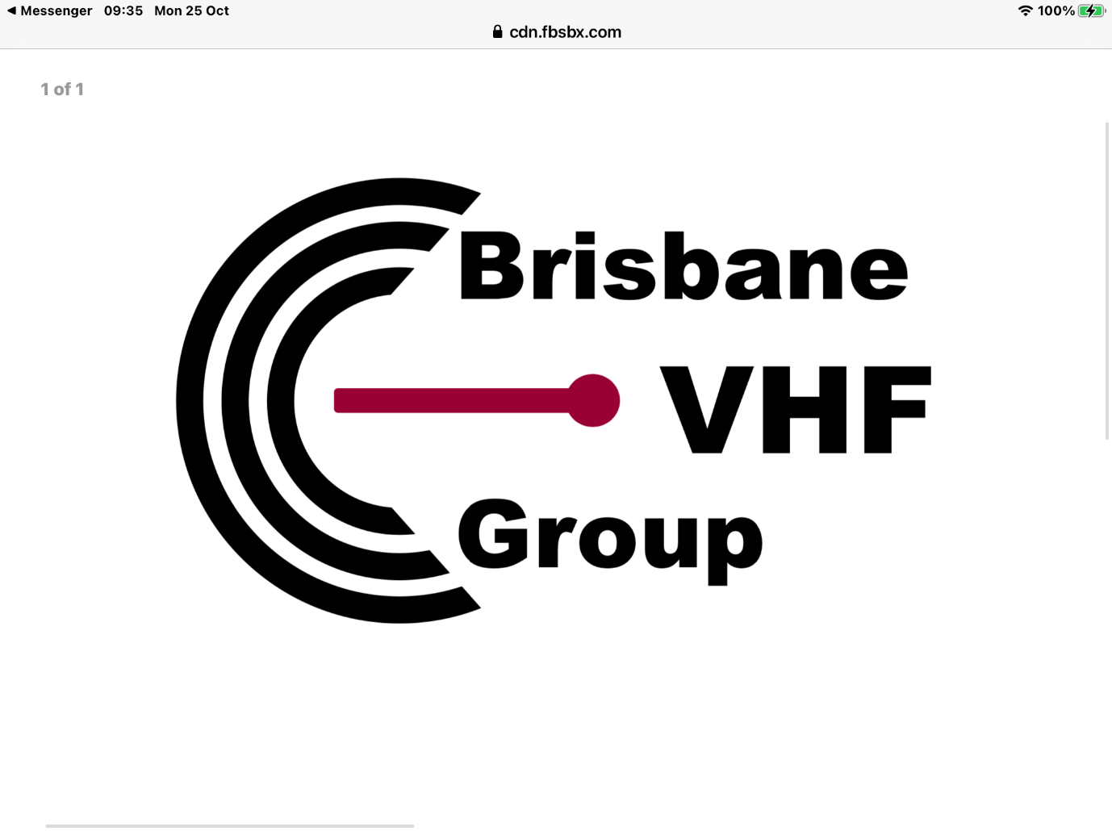
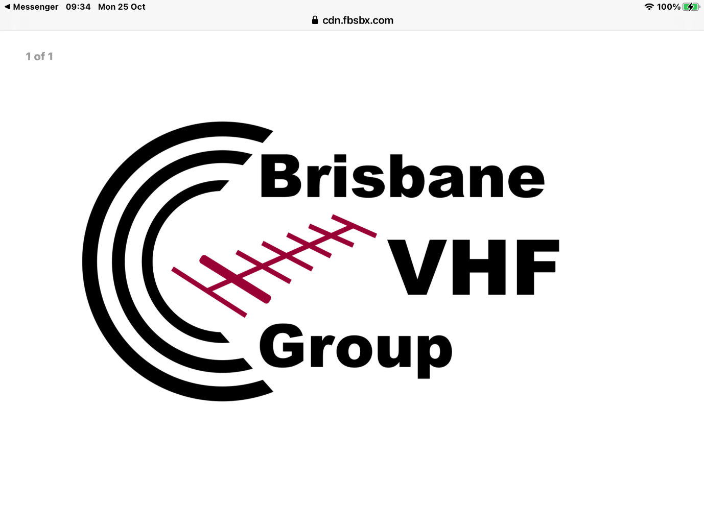

Spring VHF Field-Day 2021 (27-28 November)
As mentioned previously, plans are in place to activate the club callsign VK4IF/p in the 24h, all-bands, multi-op, portable category of next month’s National VHF Field Day. The station will be activated from the Bunya Mountains. The club won this national event last year. This is a major undertaking for the team. Any chance of a decent score again this year will depend on making multiple contacts with as many VHF and microwave stations as possible across the weekend. This contest weekend replaces the November MAD event but is still the perfect opportunity to get on-air from home or hilltop and give YOUR club station some points – every two hours if possible!

If you haven’t already done so I would encourage everyone to register for the BVHFG groups.io e-mail facility to ensure everyone gets the most up to date notifications of events and activities.
Here again is how to do this:-
To join the new Brisbane VHF Group mailing list, there are two methods
Send an email to brisbanevhfgroup+subscribe@groups.io, the email address you used will then be setup to receive every message sent to the group
Use your existing groups.io username and password to find the group and subscribe, search for Brisbane VHF Group
If you prefer a daily digest, you will need to login to the group and change your preference, link to the group is brisbanevhfgroup@groups.io | Home

I look forwards to seeing everyone at this week’s meeting in person or via Zoom.

Kevin VK4UH
Pres. BVHFG

